

**Assignment of**

Computer Vision

**Topic**

Image features Detection and Matching

Image Classification

**Submitted to**

Dr. Mohammed Moazzam Fraz

**Submitted By**

Asmat Zahra

CMS ID: 322287

PhD-CS

**Dated: 25th Oct, 2019**

**School of Electrical Engineering and Computer Science**

**National University of Science and Technology**

**Islamabad**

Task-1: Image Feature Extraction and Matching

* Oriented FAST and Rotated BRIEF (ORB)
  + Set 1

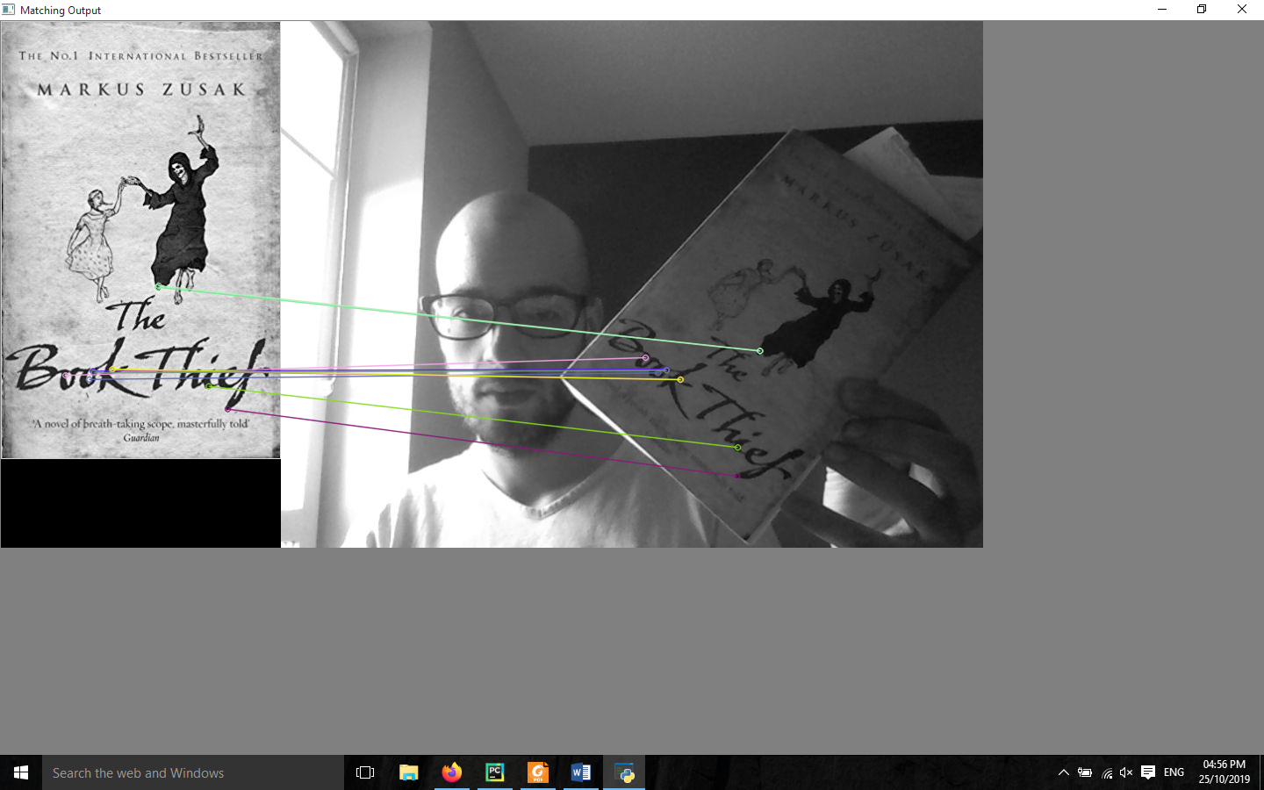

* + Set 2

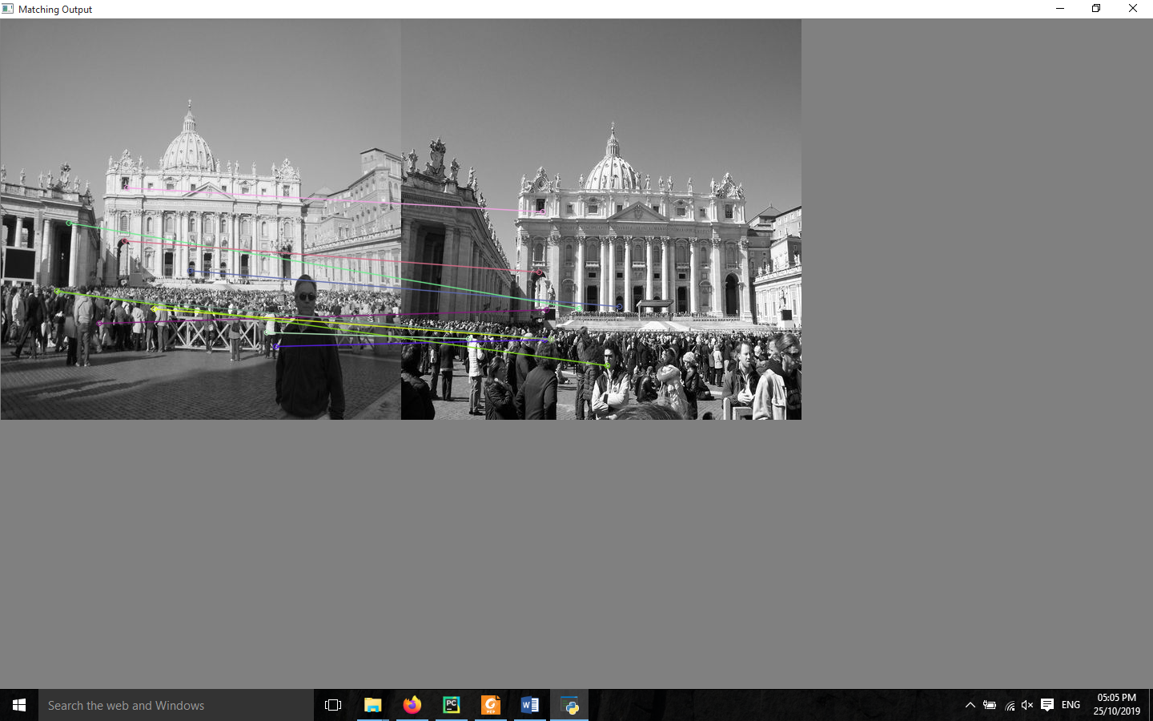

* + Set 3

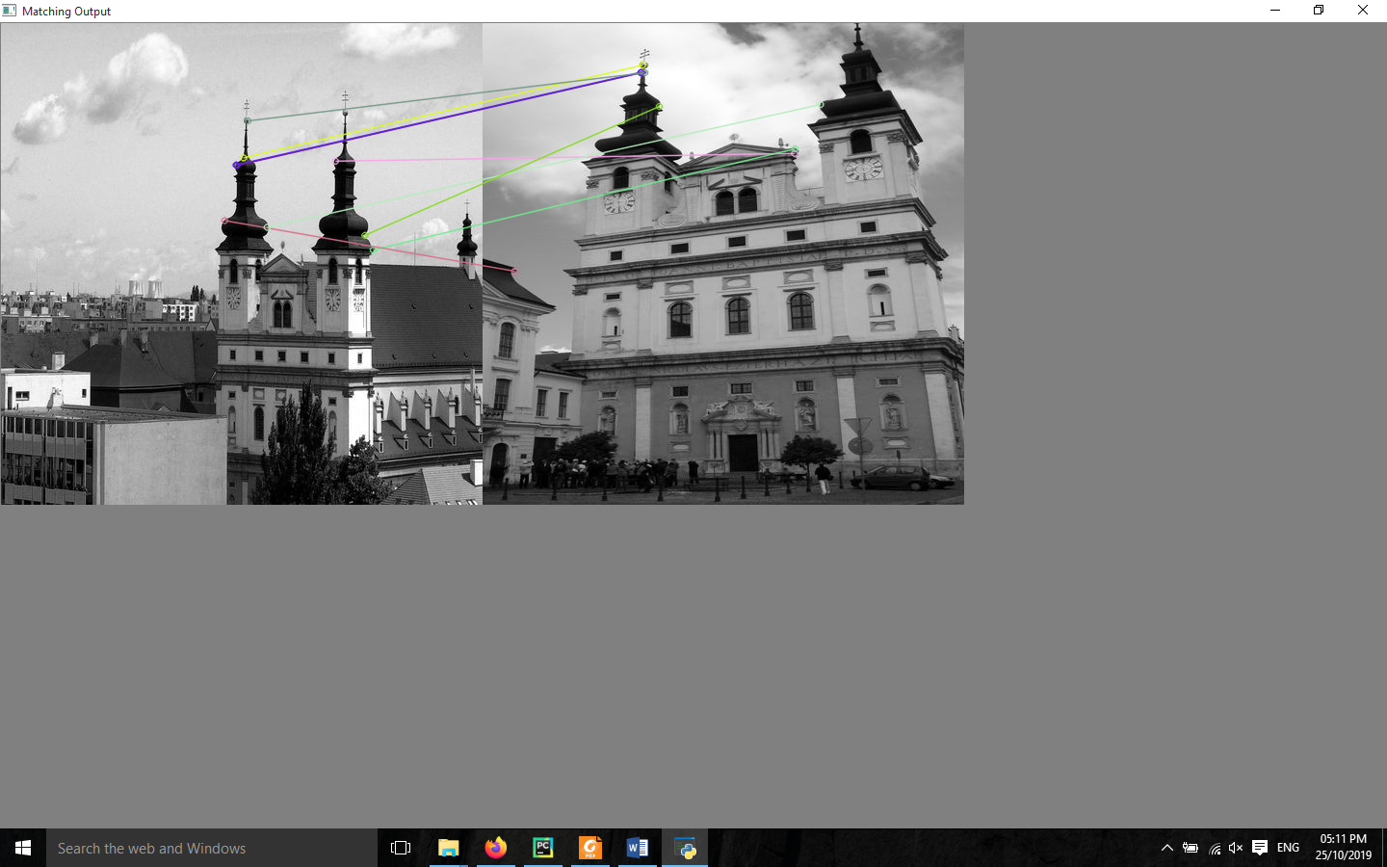

* Scale Invariant Feature Transform(SIFT)
  + Set 1

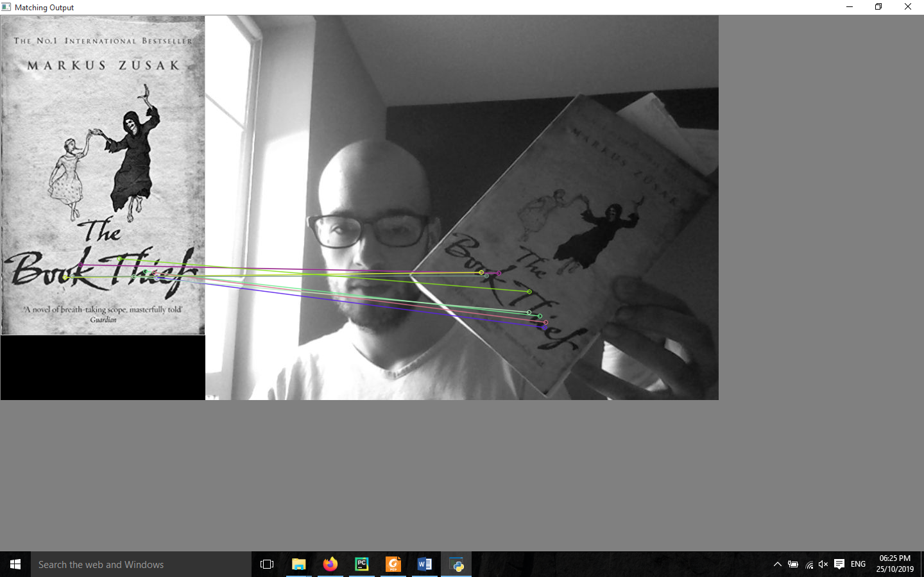

* + Set 2

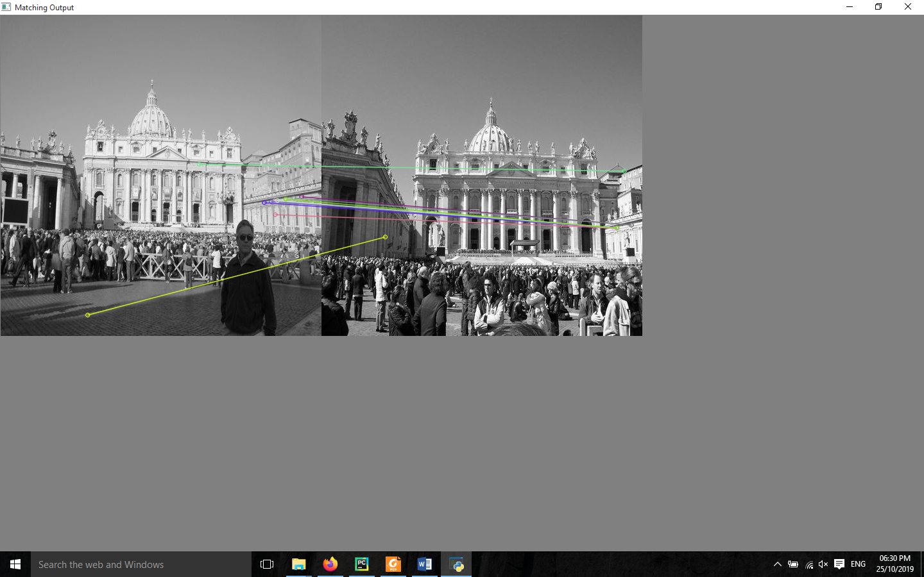

* + 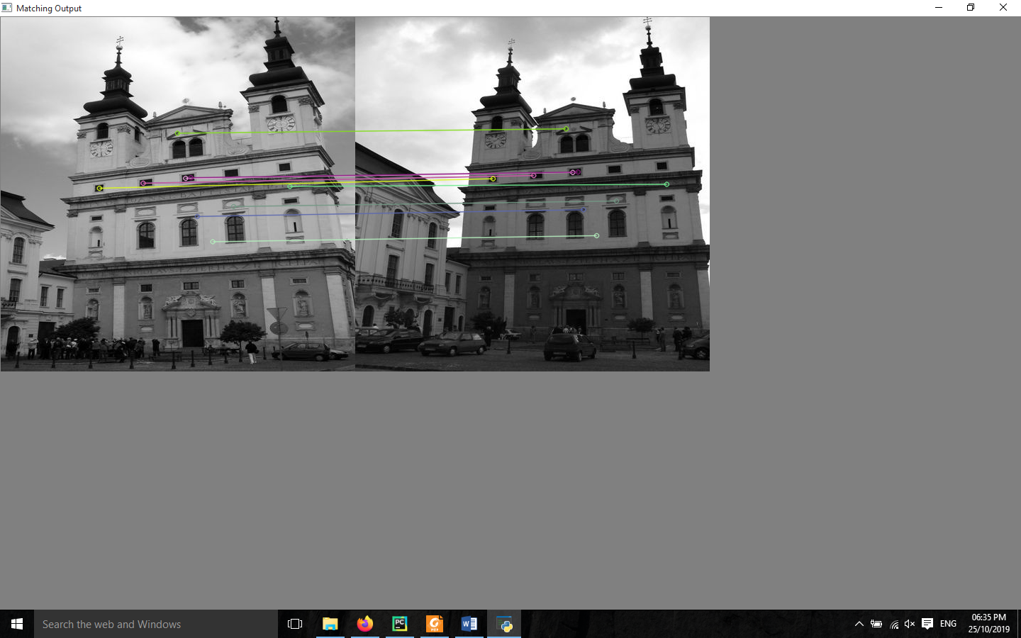Set 3
* Speeded-Up Robust Features (SURF)
  + 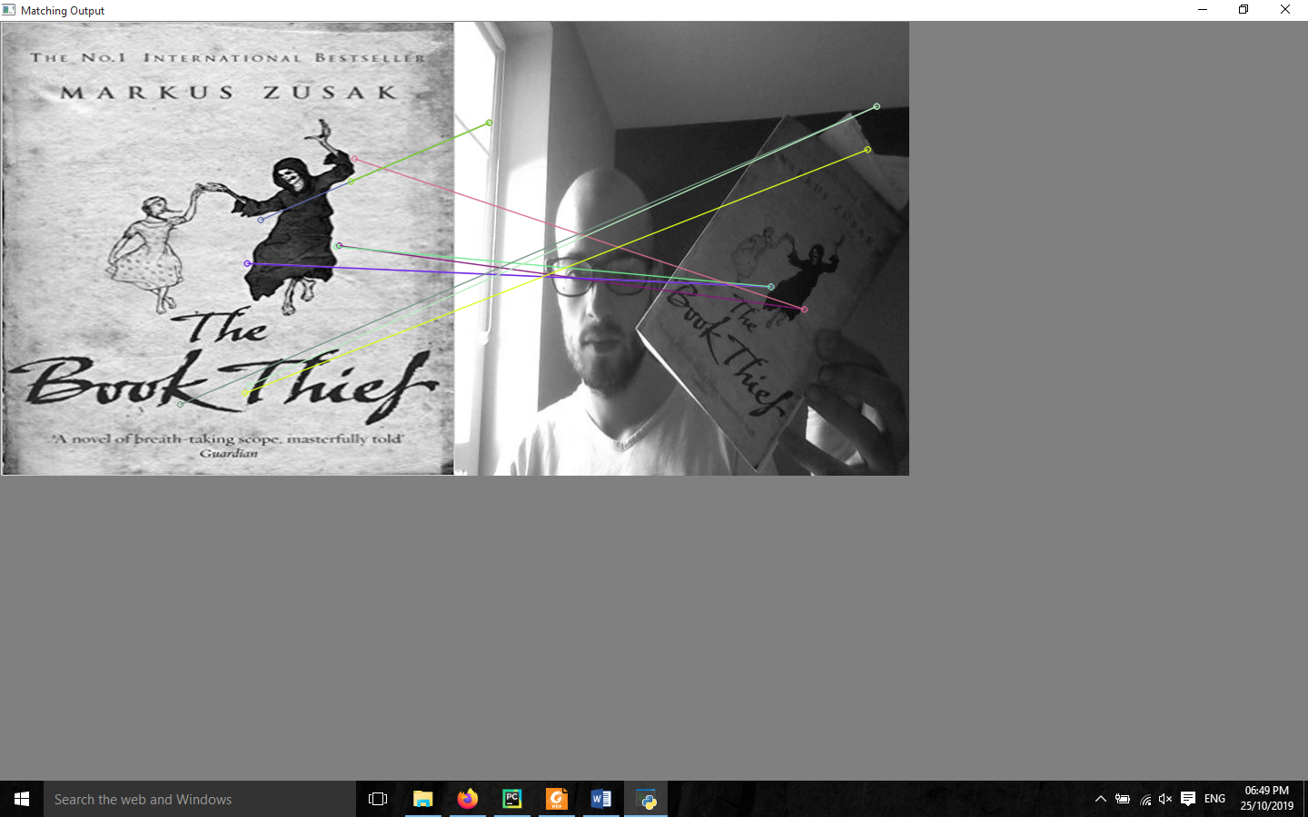Set 1
  + Set 2

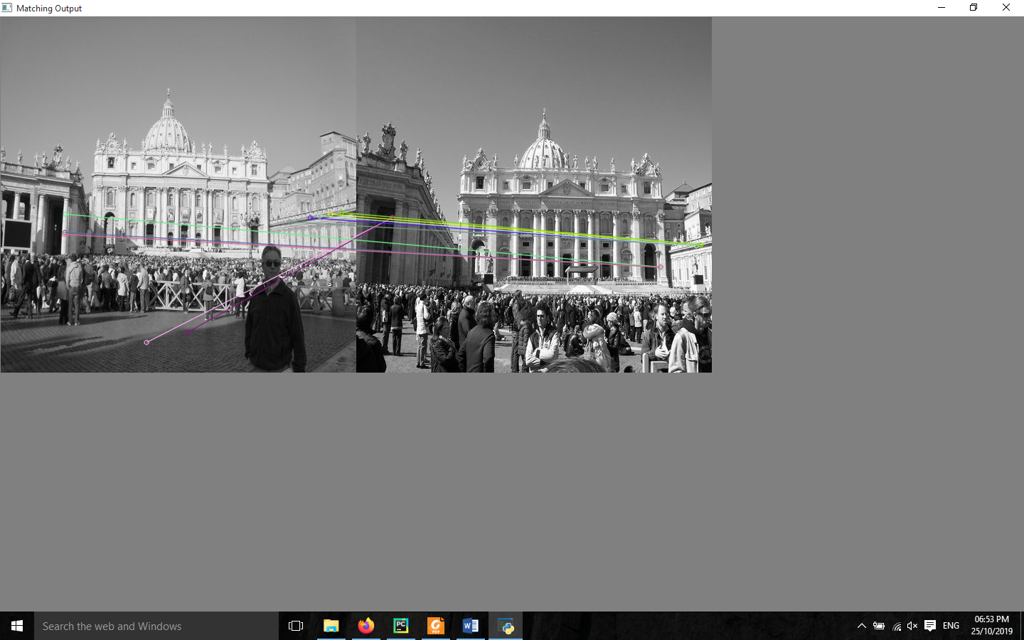

* + 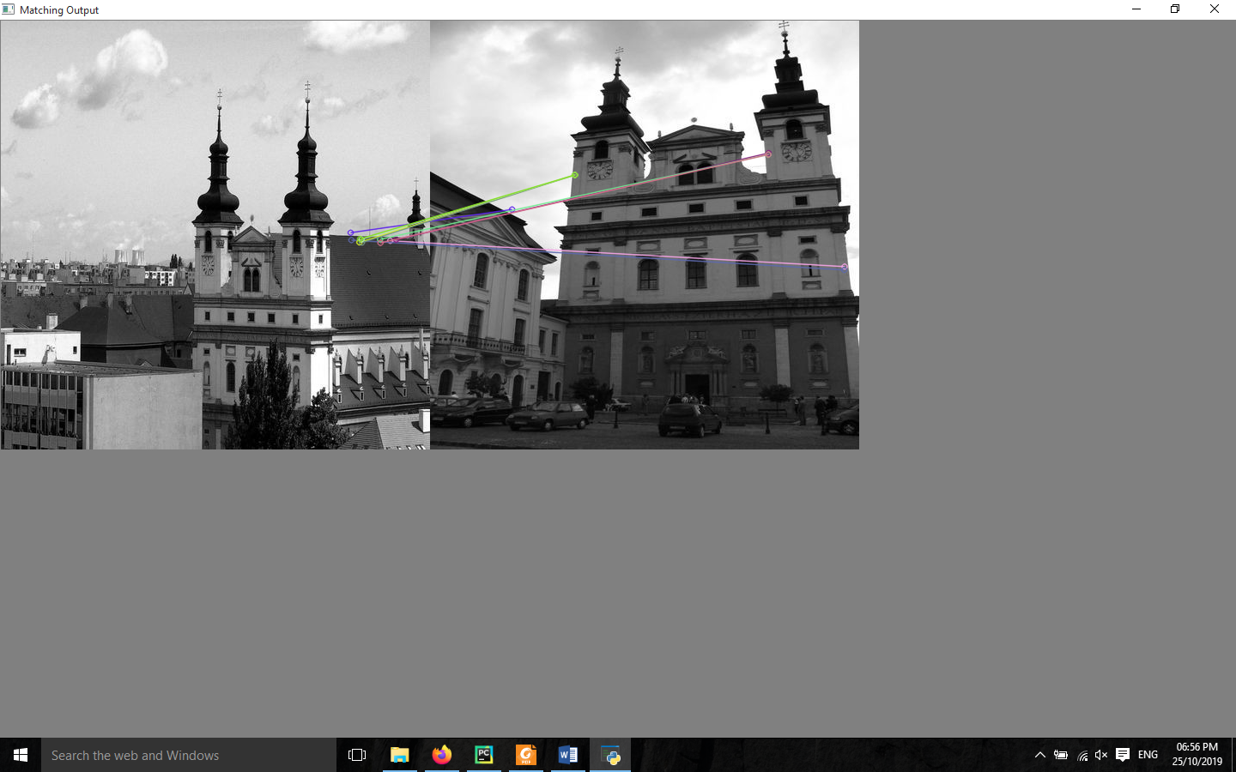Set 3

Task 2: Human Classification / Detection

**i. Quantitative performance measures i.e. F1 Score, Accuracy, True Positive Rate, and False Positive Rates of both classifiers.**

**Results for smaller dataset**

**SVM Classifier**

* **F1 score**
  + 0.8633540372670807
* **Accuracy** 
  + 0.8636363636363636
* **Confusion Matrix (True positive rate , True negative rate, False positive rate, False negative rate**
  + [[ 9 2]

[1 10]]

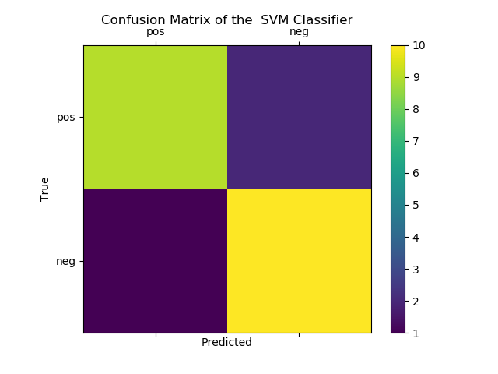

**Random Forest Classifier**

* **F1 score**
  + 1.0
* **Accuracy**
  + 1.0
* **Confusion Matrix (True positive rate , True negative rate, False positive rate, False negative rate**
  + [[11 0]

[0 11]]

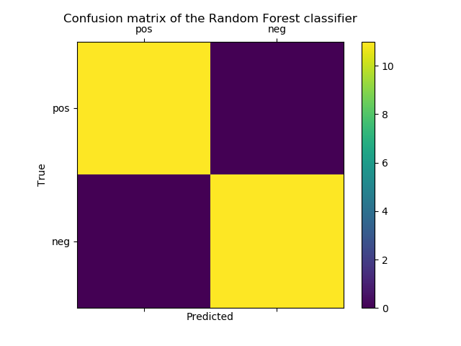

* **Classifier IDE snippet of obtained results**

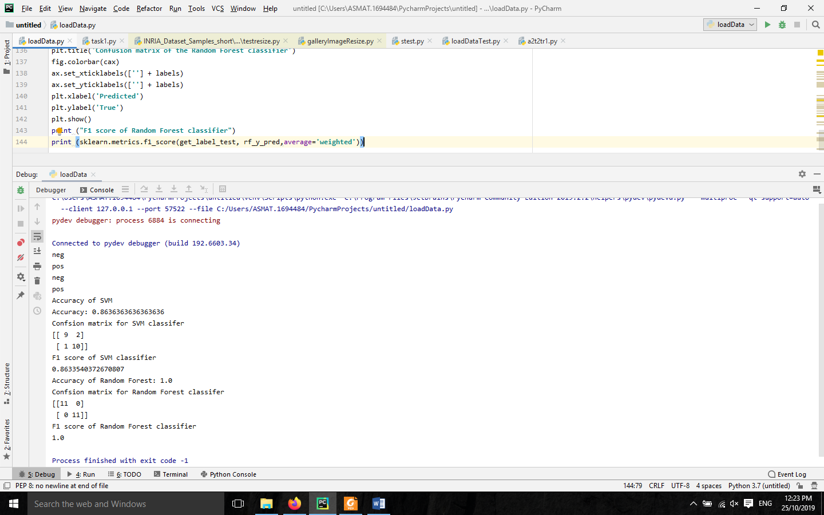

**ii. Qualitative results i.e. a few of the correctly classified images**

**Training Images**

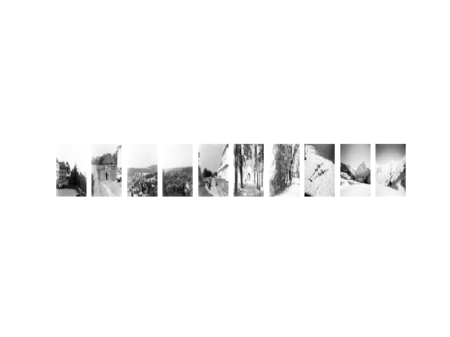

**Corresponding Training Labels**

Training label: ['neg', 'neg', 'neg', 'neg', 'neg', 'neg', 'neg', 'neg', 'neg', 'neg']

**Testing Images**

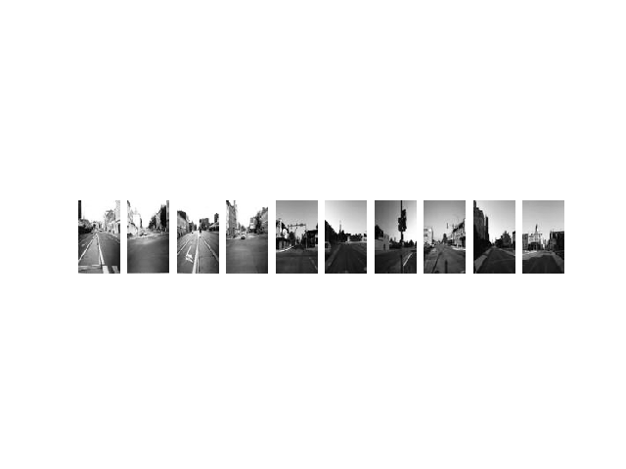

**Corresponding Testing labels**

Test label: ['neg', 'neg', 'neg', 'neg', 'neg', 'neg', 'neg', 'neg', 'neg', 'neg']

**IDE run results**

